Name

Mathematics Stage 5 Path
Further
Quadratic Equations

Book 1 | Solve quadratic equations using a variety of methods | Version: 260614  Feedback:  https://MrDingMaths.com
Contents
Syllabus Content 2
Learning Intention 3

Syllabus Content
MA5-EQU-P-02 solves linear equations of more than 3 steps, monic and non-monic quadratic equations, and linear simultaneous equations
Solve quadratic equations using a variety of methods
- Solve equations of the form ${ax}^{2}+bx+c=0$ by factorisation and by completing the square
- Apply the quadratic formula $x=\frac{-b±\sqrt{b^{2} - 4ac}}{2a}$ to solve quadratic equations
- Apply the most appropriate method to solve a variety of quadratic equations
- Use substitution to verify solutions to quadratic equations
- Identify whether a given quadratic equation has real solutions, and if there are real solutions, whether or not they are equal
- Solve quadratic equations resulting from substitution into formulas in various contexts
- Model and solve word problems using quadratic equations in various contexts
- Solve equations that are reducible to quadratics

Non-Monic Quadratic Equations

- Null Factor Law
The null factor law says that if two factors multiply to zero, one or both factors must be zero.
If $a×b=0$  Then $a=0$ or $b=0$ | If $\left(ax+b\right)\left(cx+d\right)=0$  Then $ax+b=0 or cx+d=0$  $$x=-\frac{b}{a} or x=-\frac{d}{c}$$

- Identify Solution using null-factor law
- $x\left(x-5\right)=0$ | - $\left(x-5\right)\left(x-2\right)=0$ | - $(2x-5)(x-2)=0$
- $(2x+5)(x-2)=0$ | - $10\left(2x+5\right)\left(x-2\right)=0$ | - $\left(2x+5\right)\left(7x-1\right)=0$
- $\left(x-a+b\right)\left(x-2\right)=0$ | - $\left(x+a-b\right)\left(x-2\right)=0$ | - Explain why we cannot use the null factor law:  $$\left(x-5\right)\left(x-2\right)=9$$

- Solving Non-Monic Quadratic Equations
To solve quadratic equations that are non-monic quadratic trinomials:
- Write equation in the form $x^{2}+bx+c=0$, if it isn’t already.
- Factorise the LHS using PSF.
- Use null-factor law to solve for $x$.

- Example Solve non-monic quadratic equations by factorising
$2x^{2}+11x+12=0$ | $$10x^{2}-13x=3$$
  2. $2x^{2}+3x+8x+12=0$  $x\left(2x+3\right)+4\left(2x+3\right)=0$  $\left(x+4\right)\left(2x+3\right)=0$  3.  $$x=-4 x=-\frac{3}{2}$$ | P: $24$  S: $11$  F: $3,8$
  1. $10x^{2}-13x-3=0$  2. $10x^{2}-15x+2x-3=0$  $5x\left(2x-3\right)+\left(2x-3\right)=0$  $\left(5x+1\right)\left(2x-3\right)=0$  3.  $$x=-\frac{1}{5} x=\frac{3}{2}$$ | P: $-30$  S: $-13$  F: $-15,2$

- Guided Practice
Solve for $x$.
- $4x^{2}+16x+7=0$  P: 28  S: 16  F: ………  $$x=-\frac{7}{2} or-\frac{1}{2}$$ | - $2x^{2}-17x+35=5$  P: ………  S: ………  F: ………  $$x=6 or \frac{5}{2}$$
- $2x^{2}-23x+11=0$  $$x=11 or\frac{1}{2}$$ | - $18x^{2}+12x=16$  $$x=\frac{2}{3} or-\frac{4}{3}$$

Foundation
- Solve these equations.
- $2x^{2}+11x+12=0$  $$x = -4 or -\frac{3}{2}$$ | - $4x^{2}+16x+7=0$  $$x = -\frac{7}{2}or -\frac{1}{2}$$
- $2x^{2}-17x+35=0$  $$x =\frac{7}{2}or 5$$ | - $2x^{2}-23x+11=0$  $$x =\frac{1}{2}or 11$$
- $3x^{2}-4x-15=0$  $$x = 3 or -\frac{5}{3}$$ | - $5x^{2}-7x-6=0$  $$x = 2 or -\frac{3}{5}$$
- $6x^{2}+7x-20=0$  $$x =\frac{4}{3}or -\frac{5}{2}$$ | - $7x^{2}+25x-12=0$  $$x =\frac{3}{7}or -4$$

- Solve these equations.
- $2x^{2}+ 4x+2=0$  $$x = -1$$ | - ${3x}^{2}-8x+4=0$  $$x =\frac{2}{3} or 2$$
- $2x^{2}+6x+4=0$  $$x = -1 or -2$$ | - $6x^{2}-10x+4=0$  $$x =\frac{2}{3} or 1$$
- $2x^{2}-2x-4=0$  $$x = 2 or -1$$ | - $6x^{2}+2x-4=0$  $$x =\frac{2}{3}or -1$$
- $2x^{2}-6x+4=0$  $$x = 1 or 2$$ | - $6x^{2}+10x+4=0$  $$x = -\frac{2}{3} or -1$$

Development
- Using the null factor law, write down the solutions to these equations.
- $\left(x-1\right)\left(x+2\right)=0$  $$x = 1 or -2$$ | - $2\left(x-1\right)\left(x+2 \right)=0$  $$x = 1 or -2$$
  - With reference to the null factor law, explain why a common factor of 2 does not change the answer in the two examples above.

Since we can divide both sides of the equation by 2 and get an equivalent equation, the solutions stay the same.
  - Solve $x^{2}-5x-6=0$

$x=6$ or $-1$
  - Hence solve $3x^{2}-15x-18=0$

$x=6$ or $-1$
- Solve these quadratic equations. First rearrange to the form $ax^{2}+bx+c=0$
- $2x^{2}=15-7x$  $$x =\frac{3}{2}or -5$$ | - $4x^{2}=12x-9$  $$x =\frac{3}{2}$$ | - $x=3x^{2}-14$  $$x = -2 or\frac{7}{3}$$
- $17x=12-5x^{2}$  $$x =\frac{3}{5}or -4$$ | - $25=-9x^{2}-30x$  $$x = -\frac{5}{3}$$ | - $17x-6x^{2}=5$  $$x =\frac{1}{3}or\frac{5}{2}$$

- This question has a mix of linear and quadratic equations.
Solve each equation using an appropriate technique.
- $3x+3=2x+9$  $$x = 6$$ | - $5x^{2}=3x$  $$x = 0 or \frac{3}{5}$$ |  | - $50-x^{2}=25-x-x^{2}$  $$x = -25$$
- $x^{2}-11x-12=0$  $$x = 12 or -1$$ | - $x^{2}+10x=0$  $$x = 0 or -10$$ |  | - $3\left(3x+5\right)+6=3$  $$x = -2$$
- ${\left(y+2\right)}^{2}=y^{2}+13$  $$y =\frac{9}{4}$$ | - $8x^{2}-2x-3=0$  $$x = -\frac{1}{2} or \frac{3}{4}$$ |  | - $3x^{2}+27x+42=0$  $$x = -7 or -2$$
- $2x-9=$ $\frac{x}{4}$  $$x =\frac{36}{7}$$ | - $\left(x-3\right)\left(x+5\right)=-16$  $$x = -1$$ |  | - $6x^{2}=x+2$  $$x = -\frac{1}{2} or \frac{2}{3}$$
- ${\left(b+5\right)}^{2}={\left(b+1\right)}^{2}$  $$b = -3$$ | - $x^{3}-6x^{2}+8x=0$  $$x = 0, 2, or 4$$ |  | - $4x\left(x+1\right)=3$  $$x =\frac{1}{2} or -\frac{3}{2}$$
- $\left(a+2\right)\left(x-4\right)={\left(a+3\right)}^{2}$  $$x =\frac{a^{2}+ 10a + 17}{a + 2}$$ |  | - ${\left(2y+3\right)}^{2}=\left(y+1\right)\left(y-3\right)+3y^{2}$  $$y = -\frac{6}{7}$$
- Solve these quadratic equations by first removing the decimals or fractions.
You can do this by multiplying both sides by some common factor.
- $0.1x^{2}-0.3x-2.8=0$  $$x = 7 or -4$$ | - $0.01x^{2}+0.12x+0.2=0$  $$x = -2 or -10$$ | - $0.25x^{2}+x+1=0$  $$x = -2$$
- $\frac{1}{3}x^{2}-2x+3=0$  $$x = 3$$ | - $0.4x^{2}+x-2.4=0$  $$x =\frac{3}{2}or -4$$ | - $\frac{1}{2}x^{2}+\frac{7}{3}x=\frac{5}{6}$  $$x =\frac{1}{3}or -5$$

- Solve these equations.
- $2x(x-2)=6$  $$x = 3 or -1$$ | - $3x(x+6)=4(x-2)$  $$x = -4 or -\frac{2}{3}$$
- $4x(x+5)=6x-4x^{2}-3$  $$x = -\frac{1}{4}or -\frac{3}{2}$$ | - $\frac{20-3x}{x}=2x$  $$x =\frac{5}{2}or -4$$
- $\frac{6x+8}{5x}=x$  $$x = 2 or -\frac{4}{5}$$ | - $\frac{7x+10}{2x}=3x$  $$x = 2 or -\frac{5}{6}$$
- $\frac{4}{x-2}=x+1$  $$x = 3 or -2$$ | - $\frac{1}{x}=3-2x$  $$x =\frac{1}{2} or 1$$
- $\frac{x^{2}+12}{x}=-8$  $$x = -2 or -6$$ | - $\frac{2x^{2}-12}{x}=5$  $$x = -\frac{3}{2}or 4$$
- $\frac{x+4}{2}-\frac{3}{x-3}$ $=1$  $$x = 4 or -3$$ | - $\frac{x}{x-2}-\frac{x+1}{x+4}=1$  $$x = 5 or -2$$


- Anna is solving $x^{3}+3x^{2}+2x=0$.
First, I will divide both sides by $x$ to get a quadratic.

Explain why she has made a mistake.

By dividing by $x$, she will lose the solution $x=0$ in her final answer.
By dividing by $x$, she has assumed that $x=0$ is not a solution (since you can’t divide by zero).
Hence solve $x^{3}+3x^{2}+2x=0$.

$$x=0, -2, -1$$

Mastery
- Quartic ($x$ to power of 4) equations can be reduced to quadratic equations by using a substitution $u=x^{2}$.
Worked Solution | Explanation
Solve $x^{4}+5x^{2}-36=0$  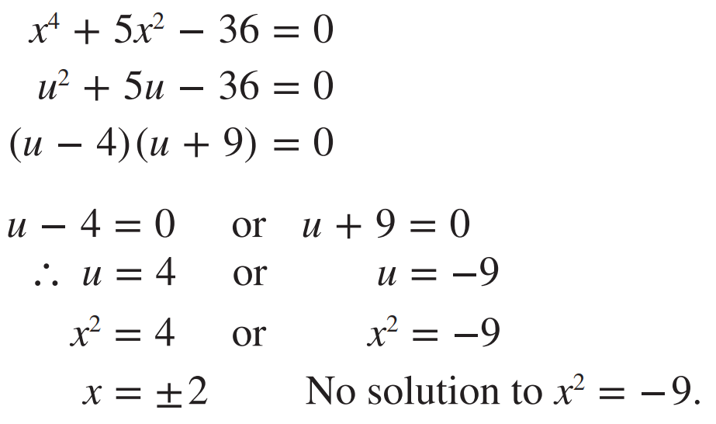 | By replacing $x^{2}$ with $u$, we made a quartic equation into a ………………… equation.  $u=4, u=-9$ is not our final answer because  $u$ represents ……, we want to find the value of $x.$  There is no solution to $x^{2}=-9$ because we cannot square root a …………… number  (for now).
Hence use the same method as above to solve these equations.
- $x^{4}-13x^{2}+36=0$  $$x=±2, ±3$$ | - $x^{4}+13x^{2}+36=0$  No solution

- Solve these quadratics in disguise by using an appropriate substitution.
- $x^{4}-29x^{2}+100=0$  $$x=±2, ±5$$ | - $x^{6}-14x^{3}-32=0$  $$x=-\sqrt[3]{2}, 2\sqrt[3]{2}$$
- ${\left(x+2\right)}^{2}-9\left(x+2\right)=0$  $$x=-2, 7$$ | - $\frac{1}{x^{2}}$ $+$ $\frac{1}{x}$ $-30=0$  $$x=-\frac{1}{6},\frac{1}{5}$$
- $x-2\sqrt{x}-8=0$  $$x=16$$ | - $9^{x}-82×3^{x}+81=0$  $x=0$, $4$

Quadratic Modelling

- Quadratic Modelling
Many scenarios can be modelled and solved using a quadratic equation.
  - Let a variable represent the unknown number.
  - Write an equation to describe the problem. (A diagram is helpful).
  - Solve the equation.
  - Check your answer makes sense and has correct units.

- Example Model and solve problems using quadratic equations
The area of a rectangle is fixed at 28 m² and its length is 3 m more than its breadth.
Find the width of the rectangle.
1. Let $x$ be the width.  28 m²  $x+3$ m  $x$ m  2. $x\left(x+3\right)=28$ | 3. $x^{2}+3x=28$  $x^{2}+3x-28=0$  $\left(x+7\right)\left(x-4\right)=0$  $x=-7$or 4  4. The width is 4. $\left(since x>0\right)$

- Guided Practice
- A rectangle has area of 40 m². Its length is 3 m longer than its breadth.
Find the length of the rectangle.

8 m
- A triangle has area of 24 m². Its height is 2 m more than its base.
Calculate the length of the base.

6 m
- A rectangular garden, 10 m by 6 m, is surrounded by a paved path of uniform width.
If the area of the path alone is 80 m², find its width.

2

Foundation
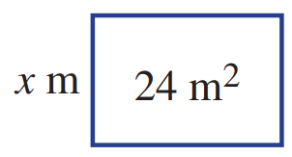
- A rectangle has an area of 24 m². Its length is 5 m longer than its breadth.
Let $x$ be the breadth of the rectangle.
  - Write an expression for the rectangle’s length.
$$x+5$$
  - Write an equation using the rectangle’s area.
$$x\left(x+5\right)=24$$
  - Write your equation from part c in standard form (i.e. $ax^{2}+bx+c=0$) and solve for $x$.

$x=3$, (ignore $x=-8$)
  - What are the dimensions of the rectangle?
$3$ m by $3+5=8$ m
- Repeat the steps from Q1 to find the dimensions of a rectangle with:
- Area 60 m² and its length is 4 m more than its breadth.  6 m by 10 m | - Area 154 cm² and its length is 3 cm less than its breadth.  14 cm by 11 cm

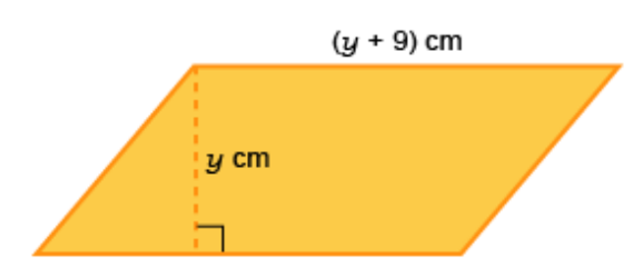
- The area of the parallelogram is 22 cm². Find its length and perpendicular height.

length 11 cm, height 2 cm
- A triangle has an area of 24 cm² and height 2 cm less than its base.
Find the height and base lengths.

base 8 cm, height 6 cm
- A triangle that has an area of 7 m² and height 5 m more than its base.
Find the height and base lengths.

base 2 m height 7m

Development
- Use Pythagoras’ theorem to solve for $x$ in these right-angled triangles.
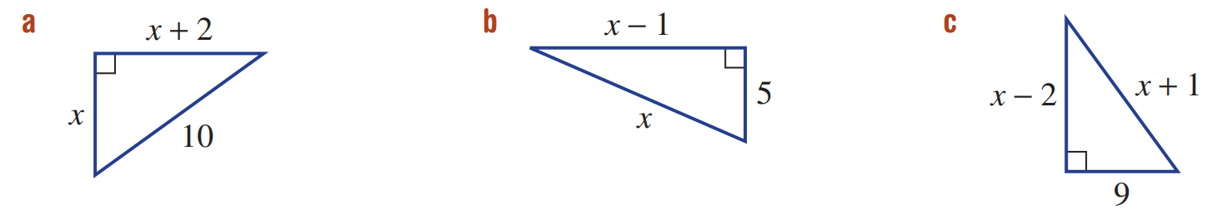  $$6$$ | $$13$$ | $$14$$

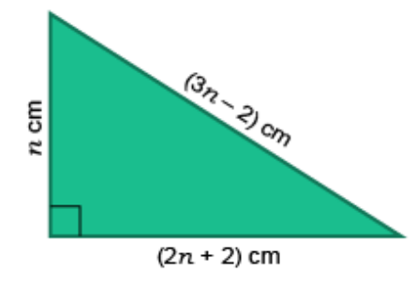
- Determine the lengths of all three sides of this right-angled triangle.

5, 12, 13
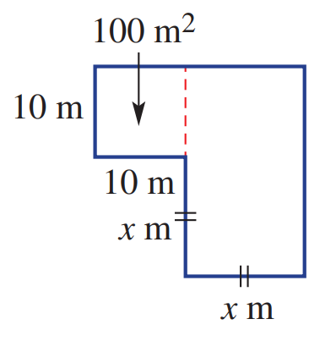
- A 100 m² hay shed is to be extended to give 475 m² of floor space in total. Find the value of $x$.

15 m
- Find a positive integer that, when increased by 30, is 12 less than its square.

7
- Two positive numbers differ by 3 and the sum of their squares is 117.
Find the numbers.

6 or 9
- A ball is thrust upwards from a machine on the ground.
The height ($h$ metres) after $t$ seconds is given by $h=t(4-t).$
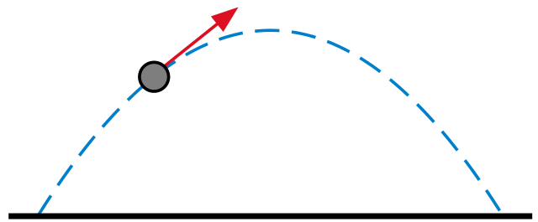

  - Find the height after 1.5 seconds.
3.75 m
  - Find when the ball is at ground level.

0 s and 4 s
  - Why are there two solutions to part b?

The ball was on the ground at the start and after it fell back down 4 s later
  - Find when the ball is at a height of 3 metres.

3 s and 1 s
  - Find when the ball is at a height of 4 metres.

2 s
  - Why is there only one solution for part e?

This must be the maximum height of the ball
- If the length of each side of a square is increased by 2, the area is multiplied by 16.
Find the length of one side of the original square.

$${\left(x+2\right)}^{2}=16x^{2}$$
$$x=\frac{2}{3} units$$
- A square hut with side length 5 metres is to be surrounded by a veranda of width $x$ metres.
Find the width of the veranda if the area of the veranda is 24 m². (Hint: draw a diagram first)

$$\left(2x+5\right)\left(2x+5\right)-24=5×5$$
1 m

- A rectangular swimming pool, 12 m by 8 m, is surrounded by a concrete path of uniform width.
If the area of the path alone is 224 m², find its width.

$$\left(2x+12\right)\left(2x+8\right)-224=12×8$$
4 m
- A rectangular painting is to have a total area (including the frame) of 1200 cm².
If the painting has length 30 cm and breadth 20 cm, find the width of the frame.

$$(2x+30)\left(2x+20\right)=1200$$
5 cm
- There are three positive odd consecutive integers such that the product of the first and third is 15 less than 12 times the middle integer. Find the integers.

Let numbers be $x,\left(x+2\right),\left(x+4\right)$
$$x\left(x+4\right)=12\left(x+2\right)-15$$
9, 11, 13

Mastery
- In a trapezium, one of the parallel sides is 4 cm longer than the other.
The perpendicular height is 2 cm longer than the shorter parallel side.
The length of the shorter parallel side is $x$ cm. The area of the trapezium is 49 cm².
  - Draw a diagram and show that $x^{2}+4x-45=0$

$$A=\frac{h\left(a+b\right)}{2}$$
$$49=\frac{\left(x+2\right)\left(x+x+4\right)}{2}$$
  - Find the value of $x$.

5 cm
- The product of two consecutive numbers is 72. Find the numbers using a quadratic equation. Note that there are two possible sets of numbers.

$$x\left(x+1\right)=72$$
8 and 9 or $-9$ and $-8$
- The perimeter of a rectangle is 40 cm and its area is 84 cm². Let its width be $x$.
Write a quadratic formula using this information and find the rectangle’s dimensions.

$$2x+2y=40$$
$$∴y=20-x$$
$$A=xy$$
$$84=x\left(20-x\right)$$
$$x^{2}-20x+84=0$$
14 cm by 6 cm
- A small rectangular block of land has a perimeter of 100 m and an area of 225 m².
Find the dimensions of the block of land.

$$y=50-x$$
$$A=xy$$
$$225=x\left(50-x\right)$$
5 m and 45 m
- The triangles are similar. Find the value of $x$.
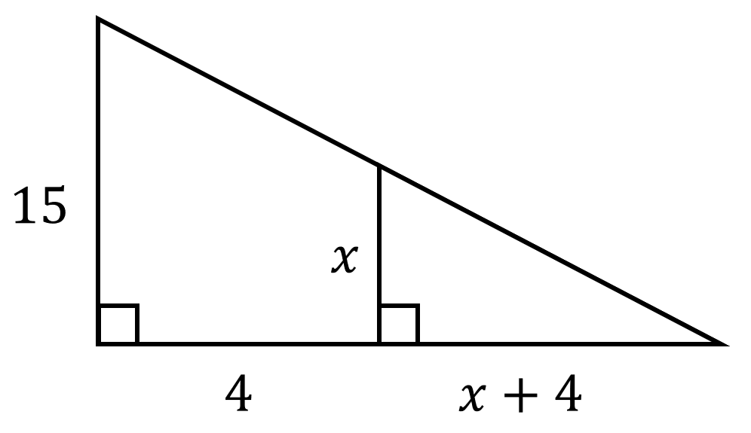  12 | 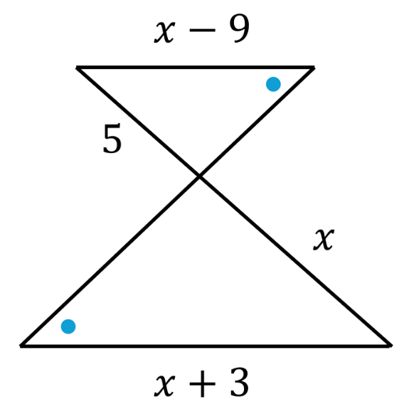  15
- Find the scale factor from $ΔABC$ to $ΔDEF$  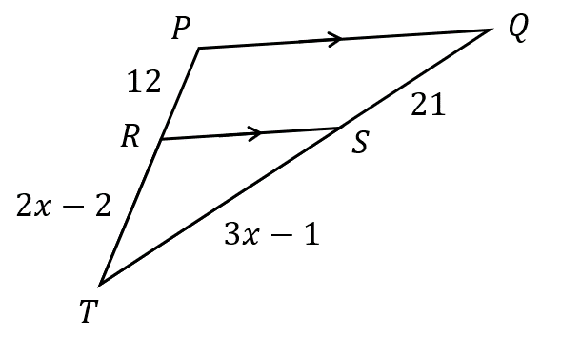  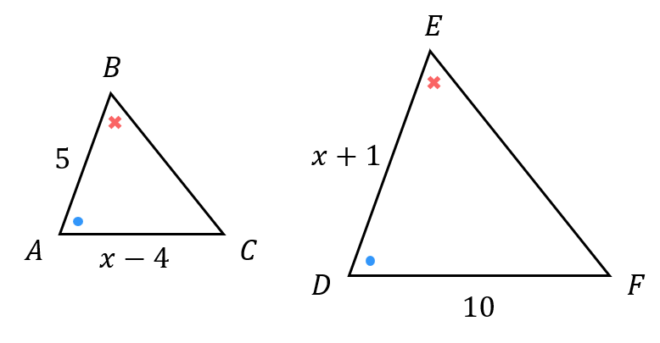  2 | - $ΔTRS\sim ΔTPQ$. Determine the scale factor.  $$\frac{5}{2}$$
- A photograph is 18 cm by 12 cm. It is to be surrounded by a frame of uniform width whose area is equal to the area of the photograph. Find the width of the frame.

$$\left(2x+18\right)\left(2x+12\right)=18×12+18×12$$
3 cm
- A cylindrical water tank with a closed top and bottom is being designed.
The height of the cylinder is 4 meters more than its radius.
The total surface area of the tank (including top and bottom) is 140$π$ square meters.
Find the radius of the tank.

$$SA=2πr^{2}+2πrh$$
$$140π=2πr^{2}+2πr\left(r+4\right)$$
5 m
- Doug went to a conference in a city 120 km away. On the way back, due to road construction, he had to drive 10 km/h slower, which resulted in the return trip taking 2 hours longer. How fast did he drive on the way to the conference?

$$d=st$$
$$120=st$$
$$120=\left(s-10\right)\left(t+2\right)$$
Solve simultaneously to find $s$
30 km/h
- A train travelled 240 km at a certain speed. When the engine was replaced by an improved model, the speed increased by 20 km/hr and the travel time decreased by 1 hr.
What was the speed of each engine?

$$d=st$$
Let original speed be $s$
$$240=st$$
$$240=\left(s+20\right)\left(t-1\right)$$
Solve simultaneously to find $s$
original speed is 60 km/h, new speed is 80 km/h
- If a cyclist had travelled 5 km/h faster, she would have needed 1.5 hr less time to travel 150 km. Find the speed of the cyclist.

$$150=st$$
$$150=\left(s+5\right)\left(t-1.5\right)$$
Solve simultaneously to find s
20 km/h
- The product of the ages of Sally and Joey now is 175 more than the product of their ages 5 years prior. If Sally is 20 years older than Joey, what are their current ages?

$$SJ=175+\left(S-5\right)\left(J-5\right)$$
$$S=J+20$$
Joey is 10 and Sally is 30.
- The product of the ages of Cally and Katy is 130 less than the product of their ages in 5 years. If Cally is 3 years older than Katy, what are their current ages?

$$C=K+3$$
$$CK=\left(C+5\right)\left(K+5\right)-130$$
Katy is 9, Cally is 12
- Mark is rowing in a river that flows downstream at 2 km/h. He rows downstream for 30 km, then turns around and returns to his original location. The total trip took 8 hrs.
How fast would Mark row in still water?

Using $t=$ $\frac{d}{s}$
Let $s$ be Mark’s speed in still water, in km/h.
$$t_{downstream}=\frac{30}{s+2}$$
$$t_{upstream}=\frac{30}{s-2}$$
$$t_{d}+t_{u}=8$$
$$∴\frac{30}{s+2}+\frac{30}{s-2}=8$$
Solve for $s$: $s=8 or-0.5$
He rows 8 km/hr

- A pilot flew at a constant speed for 600 km to its destination. Returning the next day, the pilot flew against a headwind of 50 km/h to return to the starting point. If the plane was in the air for a total of 7 hours, what was the speed of this plane on its outbound flight?

$$t_{outbound}=\frac{600}{s}$$
$$t_{return}=\frac{600}{s-50}$$
$$\frac{600}{s}+\frac{600}{s-50}=7$$
Solving for $s,$ $s=200$ km/h
($\frac{150}{7}$ is not a valid solion as that would mean the pilot has negative speed on return journey)
- Nick and Chloe want to surround their 60 by 80 cm wedding photo with frame of equal width. The resulting photo and frame is to be covered by a 1 m² sheet of glass.
Find the width of the frame.

$$\left(80+2x\right)\left(60+2x\right)=10000$$
$x=-35+5\sqrt{101}≈15.25$ cm

- The length of a room is 8 m greater than its width.
If both the length and the width are increased by 2 m, the area increases by 60 m².
Find the dimensions of the room.

$$L=W+8$$
$$\left(L+2\right)\left(W+2\right)=LW+60$$
Solve simultaneously
$$W=10, L=18$$

Completing the Square

- Interpret completing the square
Consider the quadratic equation $x^{2}-2x-5=0$. Try to factorise it.
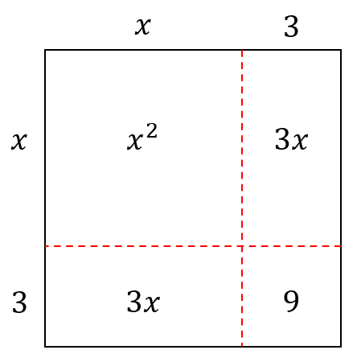
Some quadratic equations cannot be factorised easily.
We can solve them by completing the square.

Consider the area model of perfect square ${\left(x+3\right)}^{2}$.
It is a …………… with sides of ……………

Using these diagrams, make a perfect square by finding the missing number.
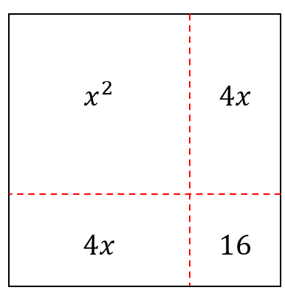  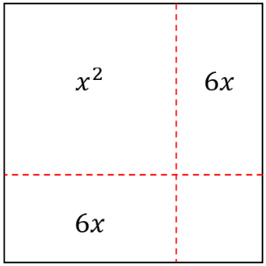  $x^{2}+8x+ 16$ $={\left( \right)}^{2}$ | $x^{2}+12x+$ ……… $={\left( \right)}^{2}$
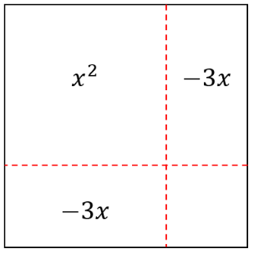  $x^{2}-6x+$ …… $={\left( \right)}^{2}$ | 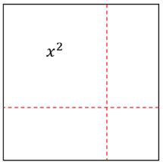  $x^{2}+24x+$ ……… $={\left( \right)}^{2}$
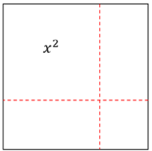  $x^{2}+10x+$ …… $={\left( \right)}^{2}$ | $x^{2}-2x+$ ……… $={\left( \right)}^{2}$

- Writing in the form ${\left(x+a\right)}^{2}+c$
We can write any quadratic expression in the form ${\left(x+a\right)}^{2}+c$ by completing the square.
A perfect square is of the form $x^{2}+2ax+a^{2}={\left(x+a\right)}^{2}$
- Halve the coefficient of $x$. This is $a.$
- Add and subtract $a^{2}$ from the original expression; this keeps it the same.
- Factorise the expression ${\left(x+a\right)}^{2}$ by recognising the perfect square.

- Example Write a quadratic expression in the form ${\left(x+a\right)}^{2}+c$
$$x^{2}+8x-1$$  1. $a=4$  2. $x^{2}+8x+4^{2}-4^{2}-1$  ¯¯¯¯¯¯¯¯¯  3. ${\left(x+4\right)}^{2}-17$  $$∴x^{2}+8x-1={\left(x+4\right)}^{2}-17$$ | $$x^{2}+5x+2$$  1. $a=$ $\frac{5}{2}$  2. $x^{2}+5x+{\left(\frac{5}{2}\right)}^{2}-{\left(\frac{5}{2}\right)}^{2}+2$  ¯¯¯¯¯¯¯¯¯¯  3. ${\left(x+\frac{5}{2}\right)}^{2}-\frac{17}{4}$  $$∴x^{2}+5x+2={\left(x+\frac{5}{2}\right)}^{2}-\frac{17}{4}$$

- Guided Practice
Write these expressions in the form ${\left(x+a\right)}^{2}+c$
- $x^{2}+6x+3$  1. $a=$ ……  2. $x^{2}+6x+$ …… $-$ …… $+3$  3. | - $x^{2}-8x+5$
- $x^{2}+7x$ | - $x^{2}-9x-11$

- Key Ideas
- We can write any quadratic expression in the form …………………… by using a method called completing the square.
- We ……………… the coefficient of $x$, ………… it, and add it and subtract it from the expression. We add and subtract to keep the expression the …………………

Foundation
- Write in the form ${\left(x+a\right)}^{2}+c$ by completing the square.
- $x^{2}+2x+3$  $${\left(x+1\right)}^{2}+ 2$$ | - $x^{2}+8x+3$  $${\left(x+4\right)}^{2}- 13$$
- $x^{2}+4x+3$  $${\left(x+2\right)}^{2}- 1$$ | - $x^{2}+10x+3$  $${\left(x+5\right)}^{2}- 22$$
- $x^{2}+6x+3$  $${\left(x+3\right)}^{2}- 6$$ | - $x^{2}+12x+3$  $${\left(x+6\right)}^{2}- 33$$

- Write in the form ${\left(x+a\right)}^{2}+c$ by completing the square.
- $x^{2}+6x+10$  $${\left(x+3\right)}^{2}+ 1$$ | - $x^{2}+6x+3$  $${\left(x+3\right)}^{2}- 6$$
- $x^{2}+6x+9$  $${\left(x+3\right)}^{2}$$ | - $x^{2}+6x$  $${\left(x+3\right)}^{2}- 9$$
- $x^{2}+6x+5$  $${\left(x+3\right)}^{2}- 4$$ | - $x^{2}+6x-4$  $${\left(x+3\right)}^{2}- 13$$

- Write in the form ${\left(x+a\right)}^{2}+c$ by completing the square.
- $x^{2}-2x+3$  $${\left(x-1\right)}^{2}+ 2$$ | - $x^{2}-8x+3$  $${\left(x-4\right)}^{2}- 13$$
- $x^{2}-4x+3$  $${\left(x-2\right)}^{2}- 1$$ | - $x^{2}-10x+3$  $${\left(x-5\right)}^{2}- 22$$
- $x^{2}-6x+3$

$${\left(x-3\right)}^{2}- 6$$
- Write in the form ${\left(x+a\right)}^{2}+c$ by completing the square.
- $x^{2}+3x+1$  $${\left(x+\frac{3}{2}\right)}^{2}-\frac{5}{4}$$ | - $x^{2}-3x+1$  $${\left(x-\frac{3}{2}\right)}^{2}-\frac{5}{4}$$
- $x^{2}+5x+1$  $${\left(x+\frac{5}{2}\right)}^{2}-\frac{21}{4}$$ | - $x^{2}-5x+4$  $${\left(x-\frac{5}{2}\right)}^{2}-\frac{9}{4}$$
- $x^{2}+7x+1$  $${\left(x+\frac{7}{2}\right)}^{2}-\frac{45}{4}$$ | - $x^{2}+9x-2$  $${\left(x+\frac{9}{2}\right)}^{2}-\frac{89}{4}$$


- Isabella and Amy are discussing $x^{2}+6x+9$
I completed the square and got $(x+3)^{2}+0$!


You didn’t need to complete the square…

Explain what Amy means.

The expression $x^{2}+6x+9$ is already a perfect square trinomial.
It equals $(x+3)^{2}$ directly, since $(x+3)^{2}=x^{2}+6x+9$.

- Two expressions, $x^{2}+10x+k$ and $x^{2}-10x+k$, are each written in the form ${\left(x+a\right)}^{2}+c$ to give the same value of $c$. Explain why and write down that value of $c$ in terms of $k$.

In both cases, $a=±5$, so $a^{2}=25$. The value of $c$ is $k-25$ in both cases.
The sign of $b$ only affects the sign of $a$; since $c=k-a^{2}$, and $a^{2}$ is the same either way, $c$ is identical.

Worked Solution | Explanation
$$=x^{2}+8x-3 \\ =x^{2}+8x+4^{2}-4^{2}-3 \\ ={\left(x+4\right)}^{2}-19$$  $$=\left(x+4-\sqrt{19}\right)\left(x+4+\sqrt{19}\right)$$ | We recognise ${\left(x+4\right)}^{2}-19$ as a d………………… of two squares.  Our answer involves a surd as 19 is not a p……………… s………………
$$=x^{2}-2x+8 \\ =x^{2}-2x+1^{2}-1^{2}+8 \\ ={\left(x-1\right)}^{2}+7$$  Cannot be factorised (as real numbers) | ${\left(x-1\right)}^{2}+7$ cannot be factorised as it not a d………………… of two squares.

- Write in the form ${\left(x+a\right)}^{2}+c$ by completing the square, then fully factorise as $\left(x+α\right)\left(x+β\right)$ using difference of two squares. Note that not all of these expressions can be fully factorised.
- $x^{2}+4x-5$  $$\left(x-1\right)\left(x+5\right)$$ | - $x^{2}-6x+2$  $$\left(x-3-\sqrt{7}\right)\left(x-3+\sqrt{7}\right)$$
- $x^{2}+4x-3$  $$\left(x+2-\sqrt{7}\right)\left(x+2+\sqrt{7}\right)$$ | - $x^{2}-6x-7$  $$(x-7)(x+1)$$
- $x^{2}+4x+5$  Cannot be factorised | - $x^{2}-6x+11$  Cannot be factorised
- $x^{2}+8x+7$  $$(x+1)(x+7)$$ | - $x^{2}+3x-4$  $$(x-1)(x+4)$$
- $x^{2}+8x-3$  $$\left(x+4-\sqrt{19}\right)\left(x+4+\sqrt{19}\right)$$ | - $x^{2}+3x-1$  $$\left(x+\frac{3}{2}-\frac{\sqrt{13}}{2}\right)\left(x+\frac{3}{2}+\frac{\sqrt{13}}{2}\right)$$
- $x^{2}+8x+17$  Cannot be factorised | - $x^{2}+3x+4$  Cannot be factorised

- Without completing the square fully, explain how you can tell immediately that $x^{2}+4x+10$ cannot be written as a difference of two squares.

Completing the square gives $(x+2)^{2}+c$. Since $a=2$, we get $c=10-4=6>0$.
A difference of two squares requires $c<0$, so the expression cannot be factorised over the reals.
- The expression $x^{2}+bx+16$ completes to give a perfect square ${\left(x+a\right)}^{2}$ with no $c$ term.
Find all possible integer values of $b$.

Completing the square gives ${\left(x+\frac{b}{2}\right)}^{2}+\left(16-\frac{b^{2}}{4}\right)$.
For no $c$ term: $16-\frac{b^{2}}{4}=0$, so $b^{2}=64$, giving $b=±8$.

Solving Quadratic Equations by Completing the Square

- Solving Quadratic Equations by Completing the Square
When we can’t use the PSF method to factorise a quadratic, we can solve a quadratic equation by completing the square.
1. Write the quadratic in the form ${\left(x+a\right)}^{2}+c$ by completing the square.
2. Solve by isolating ${\left(x+a\right)}^{2}.$
- Remember that a quadratic equation can have no real solution.

- Example Solve quadratic equations by completing the square
$$x^{2}+8x=20$$  1. $+4^{2} +4^{2}$  $x^{2}+8x+16=36$  2. ${\left(x+4\right)}^{2}=36$  3. $x+4=±6$  $x=-4±6$  $=-10 or 2$ | $x^{2}-6x+2=0$  1. $+{(-3)}^{2} +{(-3)}^{2}$  $x^{2}-6x+9+2=9$  2. ${\left(x-3\right)}^{2}+2=9$  3. ${\left(x-3\right)}^{2}=7$  $x-3=±\sqrt{7}$  $x=3±\sqrt{7}$  $=3+\sqrt{7}$ or $3-\sqrt{7}$  $≈5.65$ or $0.35$

- Guided Practice
Solve these equations by completing the square
- $x^{2}-6x+1=0$  $$x=3±2\sqrt{2}$$ | - $x^{2}+4x+1=0$  $$x=-2±\sqrt{3}$$
- $x^{2}-7x+10=0$  $$x=5 or 2$$ | - $2x^{2}-12x-22=0$  $$x=3±2\sqrt{5}$$

Quadratic Formula

- Quadratic Equations
The quadratic formula can solve any quadratic equation, if solutions exist.
First, we need every equation in the form $ax^{2}+bx+c=0$and then identify $a,b,$ and $c$.

- Identify $a$, $b,$ $c$ of a quadratic equation
$$x^{2}+3x-5=0$$  $$a=1$$  $$b=3$$  $$c=-5$$ | $$x^{2}+3x-5=2$$  $$a=1$$  $$b=3$$  $$c=-7$$ | $$2x+5x^{2}-10=0$$  $$a=5$$  $$b=2$$  $$c=-10$$
Identify $a,b,c$ of these quadratic equations.
- $x^{2}+4x+3=0$  $a=$ ………  $b=$ ………  $c=$ ……… | - $2x^{2}-x+3=0$  $a=$ ………  $b=$ ………  $c=$ ……… | - $-8x^{2}+x+3=0$  $a=$ ………  $b=$ ………  $c=$ ………
- $x^{2}+x=4$  $a=$ ………  $b=$ ………  $c=$ ……… | - $x+3x^{2}-4=0$  $a=$ ………  $b=$ ………  $c=$ ……… | - $x^{2}+4x+3=18$  $a=$ ………  $b=$ ………  $c=$ ………

- The Quadratic Formula
For $ax^{2}+bx+c=0$:
$$x=\frac{-b±\sqrt{b^{2}-4ac}}{2a}$$

- Rearrange equation to $ax^{2}+bx+c=0$, if not already.
- Identify $a,b,c$
- Substitute into formula.
- Simplify; do not put into calculator (we usually want the surd in exact form).

- Example Solve quadratic equations using the quadratic formula
$$x^{2}-x-2=0$$  2. $a=1, b=-1, c=-2$  3. $x=$ $\frac{-\left(-1\right)±\sqrt{{\left(-1\right)}^{2}-4\left(1\right)\left(-2\right)}}{2\left(1\right)}$  4. $=$ $\frac{1±\sqrt{9}}{2}$  $$=\frac{1±3}{2}$$  $=2$ or $-1$ | $2y^{2}-9y=-3$  1. $2y^{2}-9y+3=0$  2. $a=2, b=-9, c=3$  3. $y=$ $\frac{-\left(-9\right)±\sqrt{{\left(-9\right)}^{2}-4\left(2\right)\left(3\right)}}{2\left(2\right)}$  4. $=$ $\frac{9±\sqrt{57}}{4}$

- Guided Practice
Solve using the quadratic formula.
- $x^{2}+6x+2=0$  $$x=-3±\sqrt{7}$$ | - $2x^{2}-x-1=0$  $x=1$ or $-\frac{1}{2}$
- $x^{2}+x=4$  $$\frac{-1±\sqrt{17}}{2}$$ | - $16x^{2}+48x=-4$  $$\frac{-3±2\sqrt{2}}{2}$$

Foundation
- Determine the values of $a$, $b$ and $c$ in these quadratic equations.
You may need to rearrange into the form $ax^{2}+bx+c=0$
Equation | $$a$$ | $$b$$ | $$c$$
$$3x^{2}+5x+1=0$$ | 3 | 5 | 1
$$0=3x^{2}+5x+1$$ | 3 | 5 | 1
$$0=3x^{2}+5x+2$$ | 3 | 5 | 2
$$0={3x}^{2}+4x-2$$ | 3 | 4 | -2
$${3x}^{2}-4x+2=0$$ | 3 | -4 | 2
$$x^{2}-4x+2=0$$ | 1 | -4 | 2
$$x^{2}+2-4x=0$$ | 1 | -4 | 2
$$x^{2}=2-4x$$ | 1 | 4 | -2

- Find the exact solutions to the following quadratic equations, using the quadratic formula.
To help you remember it, write down the formula every time.
- $x^{2}+3x-2=0$  $a=$ $1$ $b=$ $3$ $c=$ $-2$  $$x=\frac{-b±\sqrt{b^{2}-4ac}}{2a}$$  $$x =\frac{-3 ± \sqrt{17}}{2}$$ | - $x^{2}+7x-4=0$  $$x =\frac{-7 ± \sqrt{65}}{2}$$
- $x^{2}-7x+5=0$  $$x =\frac{7 ± \sqrt{29}}{2}$$ | - $x^{2}-8x+16=0$  $$x = 4$$

- Solve these quadratics using the quadratic formula. Leave answers in exact surd form.
- $2x^{2}+7x+1=0$  $$x =\frac{-7 ± \sqrt{41}}{4}$$ | - $2x^{2}-9x=-2$  $$x =\frac{9 ± \sqrt{65}}{4}$$
- $2x^{2}-7x+1=0$  $$x =\frac{7 ± \sqrt{41}}{4}$$ | - $2x^{2}=9x-2$  $$x =\frac{9 ± \sqrt{65}}{4}$$
- $x^{2}-7x+1=0$  $$x =\frac{7 ± 3\sqrt{5}}{2}$$ | - $9x-2=2x^{2}$  $$x =\frac{9 ± \sqrt{65}}{4}$$
- $x^{2}-7x-1=0$  $$x =\frac{7 ± \sqrt{53}}{2}$$ | - $2-9x=2x^{2}$  $$x =\frac{-9 ± \sqrt{97}}{4}$$
- $2x^{2}-14x-2=0$  $$x =\frac{7 ± \sqrt{53}}{2}$$ | - $2-x=2x^{2}$  $$x =\frac{-1 ± \sqrt{17}}{4}$$
- $-2-14x+2x^{2}=0$  $$x =\frac{7 ± \sqrt{53}}{2}$$ | - $-2+x=-2x^{2}$  $$x =\frac{-1 ± \sqrt{17}}{4}$$
- $-14x+2x^{2}=0$  $$x = 0 or 7$$ | - $-2+x=-2x^{2}+10$  $$x =\frac{-1 ± \sqrt{97}}{4}$$
- $-2+2x^{2}=0$  $$x = ±1$$ | - $-2+x=-2x^{2}+10+4x$  $$x =\frac{3 ± \sqrt{105}}{4}$$

Development
Solve these questions by writing a quadratic equation, then solving it.
You do not necessarily need to use the quadratic formula.
- A triangle’s base is 5 cm more than its height of $x$ cm.
Find its height if the triangle’s area is 10 cm². Answer to 1 d.p.
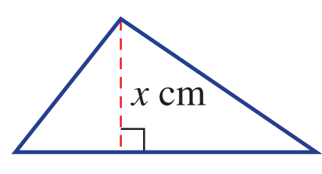

2.6 cm
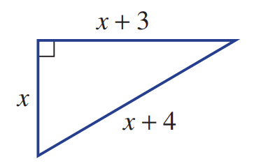
- Find the exact value of $x$ using Pythagoras’ Theorem and the Quadratic Formula.

$$x=1+2\sqrt{2}$$
Hence find the exact perimeter and area using your knowledge of surd laws.

$$P=10+6\sqrt{2}$$
$$A=6+5\sqrt{2}$$
- A pool measuring 6 m by 3 m is to have a path surrounding it.
If the total area of the pool and path is to be 31 m², find the width ($x$ m) of the path,
correct to the nearest cm.
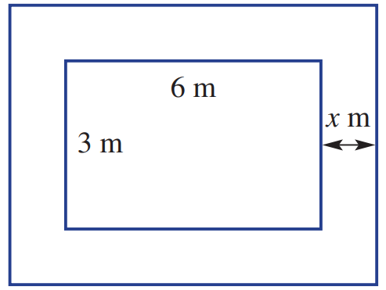

63 cm
- Use the quadratic formula, or by completing the square, find the solutions $α$, $β$ of each equation, then rewrite each equation in factored form $a\left(x-α\right)\left(x-β\right)=0$.
- $x^{2}-6x+4=0$  $$\left(x-3+\sqrt{5}\right)\left(x-3-\sqrt{5}\right)$$ | - $x^{2}-3x+1=0$  $$\left(x-\frac{3-\sqrt{5}}{2}\right)\left(x-\frac{3+\sqrt{5}}{2}\right)$$ | - $3x^{2}+6x+2=0$  $$3\left(x+\frac{3+\sqrt{3}}{3}\right)\left(x+\frac{3-\sqrt{3}}{3}\right)$$

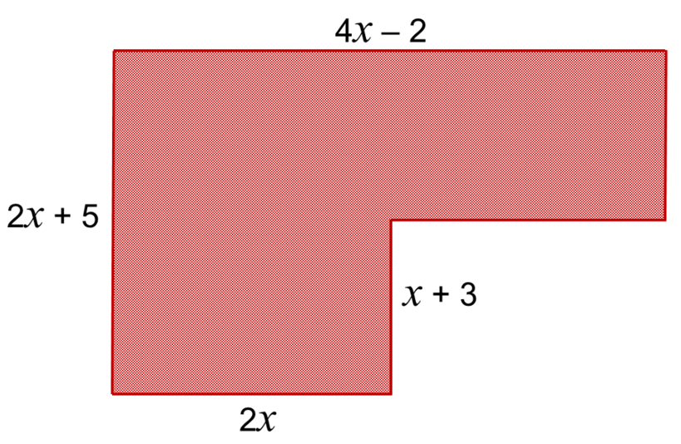
- The shaded area is $206$ cm². What is the value of $x$?

$$\left(4x-2\right)\left(2x+5\right)-\left(x+3\right)\left(2x-2\right)=206$$
$$x=5$$
- The shaded area is $18$ cm². What is the value of $x$?
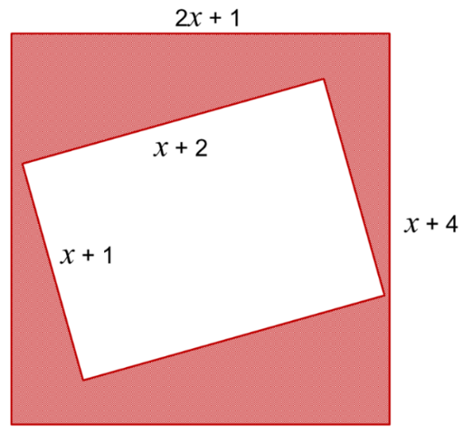

$$\left(2x+1\right)\left(x+4\right)-\left(x+1\right)\left(x+2\right)=18$$
$$x=2$$
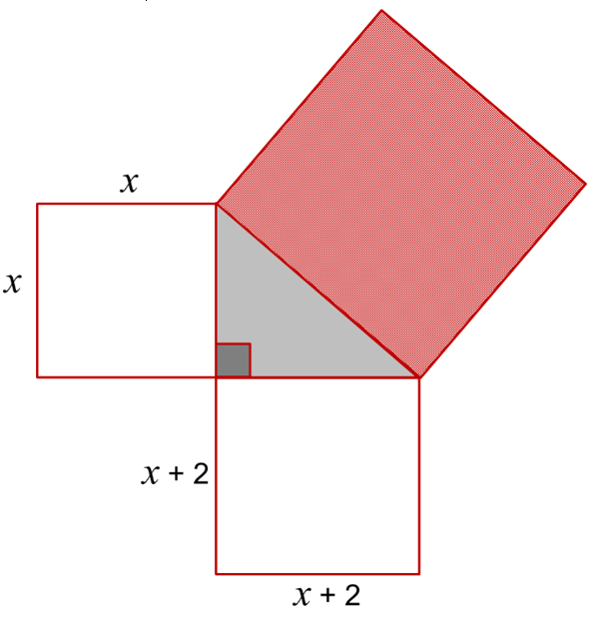
- Three squares surround a right-angled triangle. The shaded square has area of 34 cm².
What is the value of $x$?

Using Pythagoras:
$$x^{2}+{\left(x+2\right)}^{2}=34$$
$$x=3$$

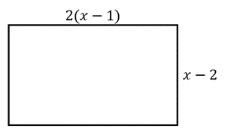
- Consider this rectangle.

  - The perimeter of the rectangle is $19$ cm. Find the value of $x$.

$x=4.5$ cm
  - Write an expanded expression for the area of the rectangle.

$$2x^{2}-6x+4$$
  - Find the length of $x$ such that the length is 5 times the width.

$$2(x-1)=5\left(x-2\right)$$
$$x=\frac{8}{3}$$
  - The area of the rectangle is $1.5$ cm². Find the length.

$$2\left(x-1\right)\left(x-2\right)=1.5$$
3 cm
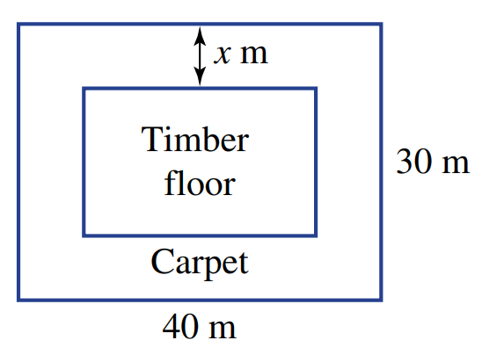
- A rectangular gallery floor is to be partially carpeted around the edge.
The hall is 30 metres wide and 40 metres long.
The breadth of the carpeted edge is $x$ metres as shown.
Inside the carpeted area is a rectangular timber floor.
Find an expression in terms of $x$ for the following:
  - The breadth of the timber floor.

$$30-2x$$
  - The length of the timber floor.

$$40-2x$$
  - The area of the timber floor.

$$4x^{2}-140x+1200$$
  - Find the value of $x$ if the timber floor area is to be 600 square metres.

$$x=5$$

- Solve the following by rewriting as $ax^{2}+bx+c=0$ then using the quadratic formula.
- $3x^{2}=1+6x$  $$x =\frac{3 ± 2\sqrt{3}}{3}$$ | - $2x^{2}=3-4x$  $$x =\frac{-2 ± \sqrt{10}}{2}$$ | - $5x=2-4x^{2}$  $$x =\frac{-5 ± \sqrt{57}}{8}$$
- $2x-5=-$ $\frac{1}{x}$  $$x =\frac{5 ± \sqrt{17}}{4}$$ | - $\frac{3}{x}$ $=3x+4$  $$x =\frac{-2 ± \sqrt{13}}{3}$$ | - $-$ $\frac{5}{x}$ $=2-x$  $$x = 1 ± \sqrt{6}$$
- $5x=$ $\frac{2x+2}{x}$  $$x =\frac{1 ±\sqrt{11}}{5}$$ | - $x=$ $\frac{3x+4}{2x}$  $$x =\frac{3 ± \sqrt{41}}{4}$$ | - $3x=$ $\frac{10x-1}{2x}$  $$x =\frac{5 ± \sqrt{19}}{6}$$
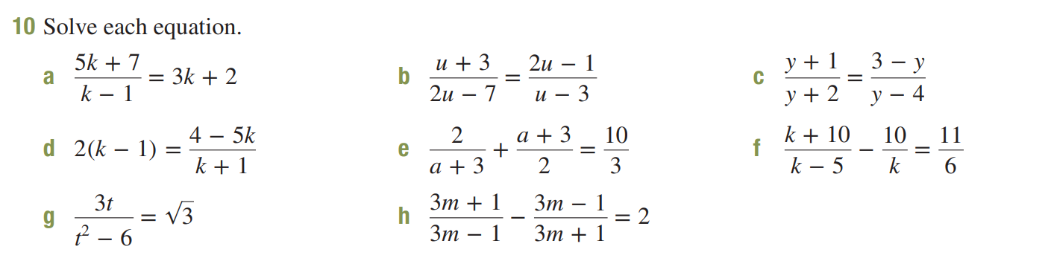  $k=-1$ or $3$ | $u=$ $\frac{4}{3}$ or 4 | $$k=\frac{-5±\sqrt{73}}{4}$$
$a=-$ $\frac{7}{3}$ or $3$ | $t=2\sqrt{3}$ or $-\sqrt{3}$ | $$m=\frac{1±\sqrt{2}}{3}$$

Mastery
- Solve these equations by making a substitution so that they can be considered a quadratic.
- $2^{2x}-2^{x}-12=0$  $$x = 2$$ | - $3^{2x}-8×3^{x}-9=0$  $$x = 2$$
- $3×9^{x}-3^{x+1}-18=0$  $x$ = 1 | - ${\left(x^{2}+x\right)}^{2}-8\left(x^{2}+x\right)+12=0$  $x$ = -3, -2, 1, or 2

- A rectangular area can be completely tiled with 200 square tiles.
If the side length of each square is increased by 1 cm, it would take only 128 tiles.
Find the side length of each tile.
(hint: let $x$ represent the side length of each tile)

4 cm
- Two trains each make a journey of 330 km.
One of the trains travels 5km/h faster than the other and takes 30 minutes less time.
  - Show that this scenario can be modelled using the equation $\frac{330}{v}-\frac{330}{v+5}=\frac{1}{2}$
  - Hence find the speeds of the trains.

55 km/h and 60 km/h
- Solve the following by forming a quadratic equation.
- The length of a square prism is 1 cm longer than the height and the width.  The surface area is 66 cm².  What are the dimensions of the prism?  3 cm × 3 cm × 4 cm | - The length, width, and height of a rectangular prism are consecutive numbers.  The surface area is 214 cm².  What are the dimensions of the prism?  5 cm × 6 cm × 7 cm
- A square prism has height 1 cm less than the length (and width).  The surface area is 80 cm².  What are the dimensions of the prism?  4 cm × 4 cm × 3 cm | - The height of a rectangular prism is 1 cm more than the width. The length is double the height.  The surface of the cuboid is 72 cm².  What are the dimensions of the prism?  2 cm × 3 cm × 6 cm

- Consider $x^{2}-2ax+4=0$, where $a$ is a constant.
  - Find the solutions in terms of $a$.
By completing the square (or quadratic formula, if preferred):
$$x^{2}-2ax+a^{2}-a^{2}+4=0 \\ {\left(x-a\right)}^{2}=a^{2}-4 \\ x-a=±\sqrt{a^{2}-4} \\ x=a±\sqrt{a^{2}-4}$$

  - Show that the product of the solutions is always a constant.
Product of solutions:
$$\left(a+\sqrt{a^{2}-4}\right)\left(a-\sqrt{a^{2}-4}\right)$$
$$=a^{2}-\left(a^{2}-4\right)$$
$$=4$$

- Derive the quadratic formula
The quadratic formula comes from completing the square on the general equation:
$$ax^{2}+bx+c=0$$
- Make the quadratic monic by dividing both sides by $a$.

$$x^{2}+\frac{b}{a} x+\frac{c}{a}=0$$
- Complete the square.

$$x^{2}+\frac{b}{a} x+{\left(\frac{b}{2a}\right)}^{2}-{\left(\frac{b}{2a}\right)}^{2}+\frac{c}{a}=0$$
$${\left(x+\frac{b}{2a}\right)}^{2}-{\left(\frac{b}{2a}\right)}^{2}+\frac{c}{a}=0$$
- Solve for $x$.
Use two methods: Isolating the squared term and factorising by completing the square.

Method 1:
$${\left(x+\frac{b}{2a}\right)}^{2}={\left(\frac{b}{2a}\right)}^{2}-\frac{c}{a}$$
$${\left(x+\frac{b}{2a}\right)}^{2}=\frac{b^{2}}{4a^{2}}-\frac{c}{a}$$
$${\left(x+\frac{b}{2a}\right)}^{2}=\frac{b^{2}-4ac}{4a^{2}}$$
$$x+\frac{b}{2a}=\frac{±\sqrt{b^{2}-4ac}}{2a}$$
$$x=\frac{-b±\sqrt{b^{2}-4ac}}{2a}$$

Method 2:
$${\left(x+\frac{b}{2a}\right)}^{2}-\frac{b^{2}}{4a^{2}}+\frac{c}{a}=0$$
$${\left(x+\frac{b}{2a}\right)}^{2}-\frac{b^{2}-4ac}{4a^{2}}=0$$
Using difference of two squares
$$\left(x+\frac{b}{2a}-\frac{\sqrt{b^{2}-4ac}}{2a}\right)\left(x+\frac{b}{2a}+\frac{\sqrt{b^{2}-4ac}}{2a}\right)=0$$
By null factor law
$$x=\frac{-b+\sqrt{b^{2}-4ac}}{2a} or\frac{-b-\sqrt{b^{2}-4ac}}{2a}$$

The Discriminant

- The Discriminant
The discriminant $Δ=b^{2}-4ac$ is the part of the quadratic formula inside the square root.
$$x=\frac{-b±\sqrt{Δ}}{2a}$$
The value of the discriminant tells us how many solutions a quadratic equation has.
$Δ<0$ no real solutions
$Δ=0$ one solution
$Δ>0$ two solutions

- Investigation The discriminant and number of solutions
Calculate the discriminant and use it to confirm the number of solutions by solving the quadratic equation.
$$x^{2}+6x+5=0$$  $$Δ=$$  There are ………… solutions.  Solving: | $$x^{2}+6x+9=0$$  $$Δ=$$  There are ………… solutions.  Solving: | $$x^{2}+6x+100=0$$  $$Δ=$$  There are ………… solutions.  Solving:

- The Discriminant
For $ax^{2}+bx+c=0$:
$$Δ=b^{2}-4ac$$

The value of the discriminant tells us how many solutions a quadratic equation has.
$Δ<0$ no real solutions
$Δ=0$ one solution
$Δ>0$ two solutions

- Example Apply discriminant to solve problems involving number of solutions
Find the values of $k$ for which $x^{2}+8x+k=0$ has two solutions.
$$a=1, b=8, c=k$$
$$Δ=8^{2}-4\left(1\right)\left(k\right)=64-4k$$
$$Δ>0$$
$$∴64-4k>0 \\ -4k>-64 \\ k<16$$

- Guided Practice
- Find the values of $k$ for which $x^{2}+8x+k=0$ has no real solutions.

$$k>16$$
- Find the values of $k$ for which $x^{2}+k=10x$ has two real solutions.

$$k<25$$
- Find the values of $k$ for which $2x^{2}+4x+k$ has exactly one real solution.

$$k=2$$
- Real or Rational Roots
$Δ<0$ no real solutions
$Δ=0$ one real equal solution
$Δ>0$ two real distinct solutions
If $Δ$ is a perfect square, the solutions will be rational i.e., can be written without a square root.
Perfect squares are : 0, 1, 4, 9, 16, 25, 36, 49, 64, 81, 100, 121, 144, 169, etc.

- Interpret value of the discriminant
The discriminant of a quadratic equation is given.
Decide whether the solutions will be real, not real, rational, or irrational.
- $Δ=15$ | - $Δ=-36$ | - $Δ=0$
  - Real  - Distinct  - Rational | - Not real  - Equal  - Irrational
  - Real  - Distinct  - Rational | - Not real  - Equal  - Irrational
  - Real  - Distinct  - Rational | - Not real  - Equal  - Irrational
- $Δ=31$ | - $Δ=-25$ | - $Δ=16$
  - Real  - Distinct  - Rational | - Not real  - Equal  - Irrational
  - Real  - Distinct  - Rational | - Not real  - Equal  - Irrational
  - Real  - Distinct  - Rational | - Not real  - Equal  - Irrational
- $Δ=-139$ | - $Δ=1$ | - $Δ=169$
  - Real  - Distinct  - Rational | - Not real  - Equal  - Irrational
  - Real  - Distinct  - Rational | - Not real  - Equal  - Irrational
  - Real  - Distinct  - Rational | - Not real  - Equal  - Irrational

- Example Apply discriminant to solve problems involving rationality of solutions
Show that $x^{2}+\left(k+1\right)x+k=0$ has rational solutions for all rational values of $k.$
$$a=1, b=k+1, c=k$$
$$Δ={\left(k+1\right)}^{2}-4\left(1\right)\left(k\right)$$
$$=k^{2}+2k+1-4k$$
$$=k^{2}-2k+1$$
$$={\left(k-1\right)}^{2}$$
Since ${\left(k-1\right)}^{2}$ is a perfect square and $≥0$for all real $k$, the solutions are always rational.

- Guided Practice
- Show that $x^{2}+2kx+\left(k^{2}-1\right)=0$ always has rational solutions for all rational $k$.

- Show that $x^{2}+\left(k+2\right)x+\left(k+1\right)=0$ always has rational solutions for all rational $k$.

- Key Ideas
- The discriminant $Δ=$ ……………… tells us how many ………………… a quadratic equation has.
- A quadratic equation has no ……… solution if $Δ<$ ………
- A quadratic equation has exactly one solution if $Δ=$ ………
- A quadratic equation has two solutions if $Δ>$ ………
- If $Δ$ is a ……………… ………………, then the solutions are rational numbers.

Foundation
- Calculate the discriminant of each equation and state the number of solutions.
- $x^{2}-x-4=0$  17, two solutions | - $2x^{2}+3x+6=0$  $-39$, no real solution | - $x^{2}-9x+20=0$  $1$, two solutions
- $x^{2}+6x+9=0$  0, one solution | - $2x^{2}-5x-1=0$  33, two solutions | - $-x^{2}+2x-5=0$  $-16$, no real solution
- $-2x^{2}-5x+3=0$  49, two solutions | - $-5x^{2}+2x-6=0$  $-116$, no real solution | - $-x^{2}+x=0$  1, two solutions

- Read the example carefully and answer the questions.
Arabella’s work:  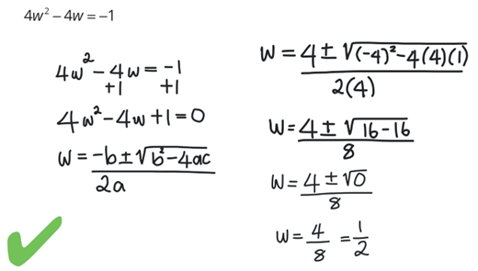 | Why did Arabella add +1 to both sides before applying the quadratic formula?  Quadratic formula requires the equation to be in the form $ax^{2}+bx+c=$ ……  Why is there only one solution to this equation?  The d…………………… is 0  Solve: $9w^{2}+12w=-4$  $$w=-\frac{2}{3}$$

- Find the discriminant of $x^{2}+4x+k=0$:

$$16-4k$$
By solving the inequality, find values of $k$ where the equation $x^{2}+4x+k=0$ has:
- No solutions $Δ<0$  $$k>4$$ | - One solution $Δ=0$  $$k=4$$ | - Two solutions $Δ>0$  $$k<4$$

Development
- By examining the discriminant, state the number of distinct solutions and if they are rational or irrational.
- $9x^{2}-4=0$  2 distinct rational solutions | - $x^{2}+3x+2=0$  2 distinct rational solutions | - $-2x^{2}+5x+2=0$  2 distinct irrational solutions
- $-4x^{2}+20x-25=0$  1 rational solution | - $3x^{2}+4x+2=0$  No real solutions | - $25x^{2}-20x+4=0$  1 rational solution

- Find the value of $p$ for which the quadratic equation $x^{2}+2x+p= 0$ has one solution.

$$p=1$$
- Find any values of $k$ for which the quadratic equation $x^{2}+kx+1=0$ has one solution.

$$k=±2$$
- Find all the values of $b$ for which $2x^{2}+x+b+1=0$ has two real solutions.

$$b<-\frac{7}{8}$$
- Find the values of $p$ if $px^{2}+4x+2=0$ has no real solutions.

$$p>2$$
- Find all values of $k$ for which $\left(k+2\right)x^{2}+x-3=0$ has 2 real solutions.

$$k>-\frac{25}{12}$$

Mastery
- Find the values of $k$ for which these equations have exactly one real solution.
- $kx^{2}-6x+k=0$  $$k=±3$$ | - $x^{2}-\left(k+4\right)x+9=0$  $$k=-10, 2$$ | - $2kx^{2}+2\left(k-2\right)x-3=0$  Not possible

- $kx^{2}-\left(2k-1\right)x+k=0$. Find the values of $k$ for which this equation has:
- No solutions $Δ<0$  $$k>\frac{1}{4}$$ | - One solution $Δ=0$  $$k=\frac{1}{4}$$ | - Two solutions $Δ>0$  $$k<\frac{1}{4}$$

- $4\left(k+1\right)x^{2}+4kx+k-2=0$. Find the values of $k$ for which this equation has:
- No solutions $Δ<0$  $$k<-2$$ | - One solution $Δ=0$  $$k=-2$$ | - Two solutions $Δ>0$  $$k>-2$$

- Show that $x^{2}-4px+\left(4p^{2}-0\right)=0$ always has integer solutions for all integer $p$.

$$Δ=\left(-4p^{2}\right)-4\left(1\right)\left(4p^{2}-9\right)=36$$
The solutions are therefore
$$x=\frac{4p±6}{2}$$
$$=2p±3$$
So, integer solutions for all integer $p$

- Show that $x^{2}+2mx+\left(m^{2}+4\right)=0$ never has any real solutions for any real $m$.

$$Δ={\left(2m\right)}^{2}-4\left(1\right)\left(m^{2}+4\right)=-16$$
Since the discriminant is always negative, this equation never has any real solutions.

- Show that $x^{2}-\left(2q+1\right)x+q\left(q+1\right)=0$ always yields consecutive integer solutions for all integer $q$.

$$Δ={\left(-\left(2q+1\right)\right)}^{2}-4\left(1\right)\left(q\left(q+1\right)\right)=1$$
The solutions are
$$x=\frac{2q+1±1}{2}$$
$=q+1$ or $q$

- Show that for all $m$, the equation $x^{2}-\left(m^{2}+m\right)x+m^{3}=0$ always yields two solutions where one solution is the perfect square of the other.

$$Δ={\left(-\left(m^{2}+m\right)\right)}^{2}-4\left(1\right)\left(m^{3}\right)$$
$$=m^{4}-2m^{3}+m^{2}$$
$$=m^{2}{\left(m-1\right)}^{2}$$
The solutions are
$$x_{1}=\frac{m^{2}+m+m\left(m-1\right)}{2}=m^{2}$$
$$x_{2}=\frac{m^{2}+m-m\left(m-1\right)}{2}=m$$

- The equation $\left(k^{2}-1\right)x^{2}-2\left(k^{2}+1\right)x+\left(k^{2}-1\right)=0$ can yield distinct, rational solutions that are reciprocals of each other. For what values of $k$ is this true?
$$Δ={\left(-2\left(k^{2}+1\right)\right)}^{2}-4\left(k^{2}-1\right)\left(k^{2}-1\right)$$
$$=16k^{2}$$
The solutions are
$$x=\frac{2\left(k^{2}+1\right)±4k}{2\left(k^{2}-1\right)}$$
$$=\frac{k^{2}±2k+1}{k^{2}-1}$$
$$=\frac{{\left(k+1\right)}^{2}}{\left(k-1\right)\left(k+1\right)}=\frac{k+1}{k-1}$$
Or
$$\frac{{\left(k-1\right)}^{2}}{(k-1)(k+1)}=\frac{k-1}{k+1}$$
The solutions would be undefined for $k=±1$
Suppose $\frac{k-1}{k+1}=\frac{k+1}{k-1}$
$${\left(k-1\right)}^{2}={\left(k+1\right)}^{2}$$
$$-2k=2k$$
$∴$ roots are equal when $k=0$
So distinct, rational solutions as long as $k$ is a rational number and $k≠-1,0,1$

  - Expand ${\left(k^{4}-6k^{2}+1\right)}^{2}$

  - Hence, or otherwise, prove that for all integers $k>1$, the solutions of the equation
$$x^{2}-\left(k^{4}+2k^{2}+1\right)x+\left(4k^{6}-8k^{4}+4k^{2}\right)=0$$
yield the squares of the side lengths of this triangle.
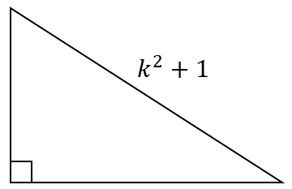
Find the discriminant:
$$Δ=k^{8}-12k^{6}+38k^{4}-12k^{2}+1$$
Using part a)
$$Δ={\left(k^{4}-6k^{2}+1\right)}^{2}$$
Substitute this into $x=$ $\frac{-b±\sqrt{Δ}}{2a}$
The two solutions simplify to
$$x_{1}=k^{4}-2k^{2}+1$$
$$x_{2}=4k^{2}$$

$$x_{1}+x_{2}=k^{4}+2k^{2}+1={\left(k^{2}+1\right)}^{2}$$

Therefore, by Pythagoras’ Theorem, the two solutions are the squares of the side lengths of a right-angled triangle with hypotenuse $k^{2}+1$

